|  |  |
| --- | --- |
|  | **BAHRIA UNIVERSITY**  **(Karachi Campus)**  *Department of Software Engineering*  **ASSIGNMENT#01 – Fall 2023** |

|  |  |  |  |
| --- | --- | --- | --- |
| COURSE TITLE: | **Information Security** | COURSE | CODE: **CSC-407** |
| Class: | **BSE – 7A&7B** | Shift: | **Morning** |
| Course Instructor: | **DR. OSAMA REHMAN** | Date: | **23-Oct.-2023** |
| Due Date: | **30-Oct.-2023** | Marks: | **5.0 Marks** |
| **Instructions:** |  |  |  |

1. **Attempt all questions.**
2. **This is an individual effort task.**
3. **Only handwritten answers are accepted.**
4. **Write your full name, registration number and section on the title page.**
5. **Question#1 is a “Complex Engineering Problem (CEP)” having an attributed of no obvious solution.**
6. **Question#3 is a “Complex Engineering Problem (CEP)” having an attributed of no obvious solution & conflicting issues.**

Q1. Among the impacts of “Security Breaches” are reputation damage, weakening customer loyalty, diminishing investor confidence, monetary loss and legal consequences. Investigate an actual cybersecurity incident that took place in history and list down the major impacts it had on the affected victims. **[CLO#5, CEP, 2.0 marks]**

* Your answer should be in the form of listed points or short descriptions.
* Provide the link/reference to the source(s) from which information is gathered.

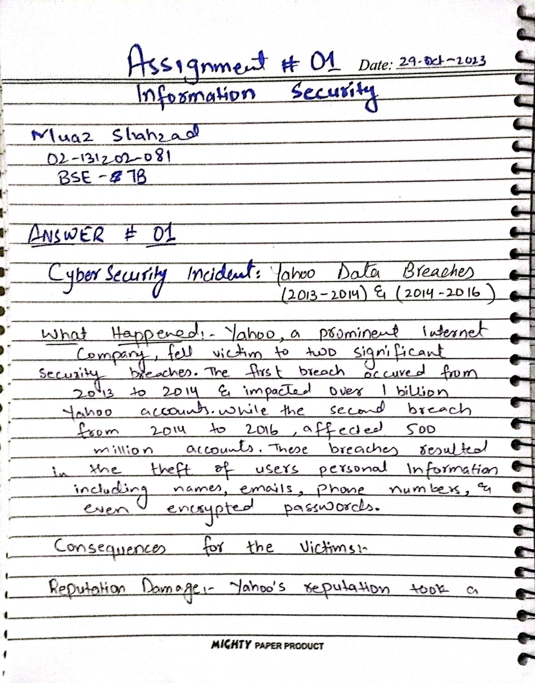

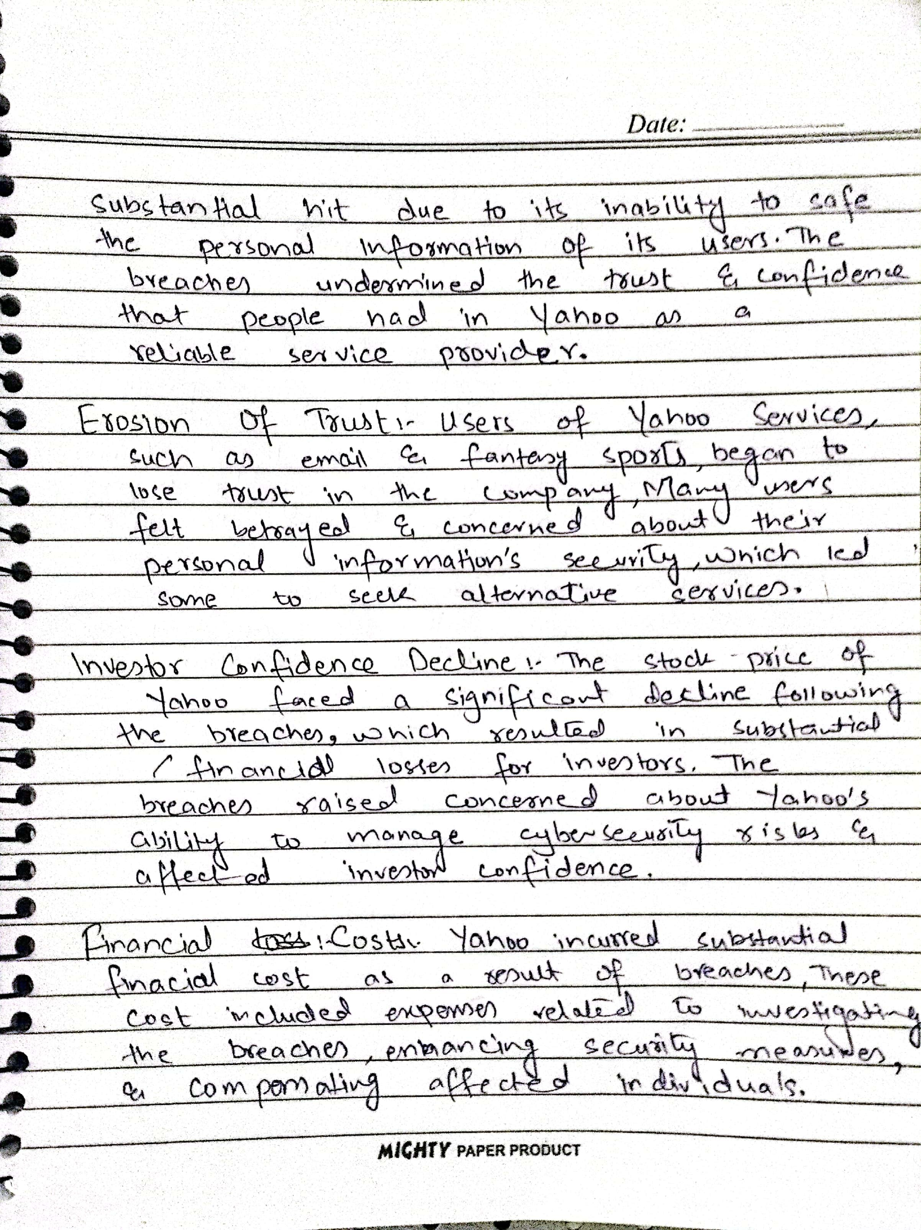

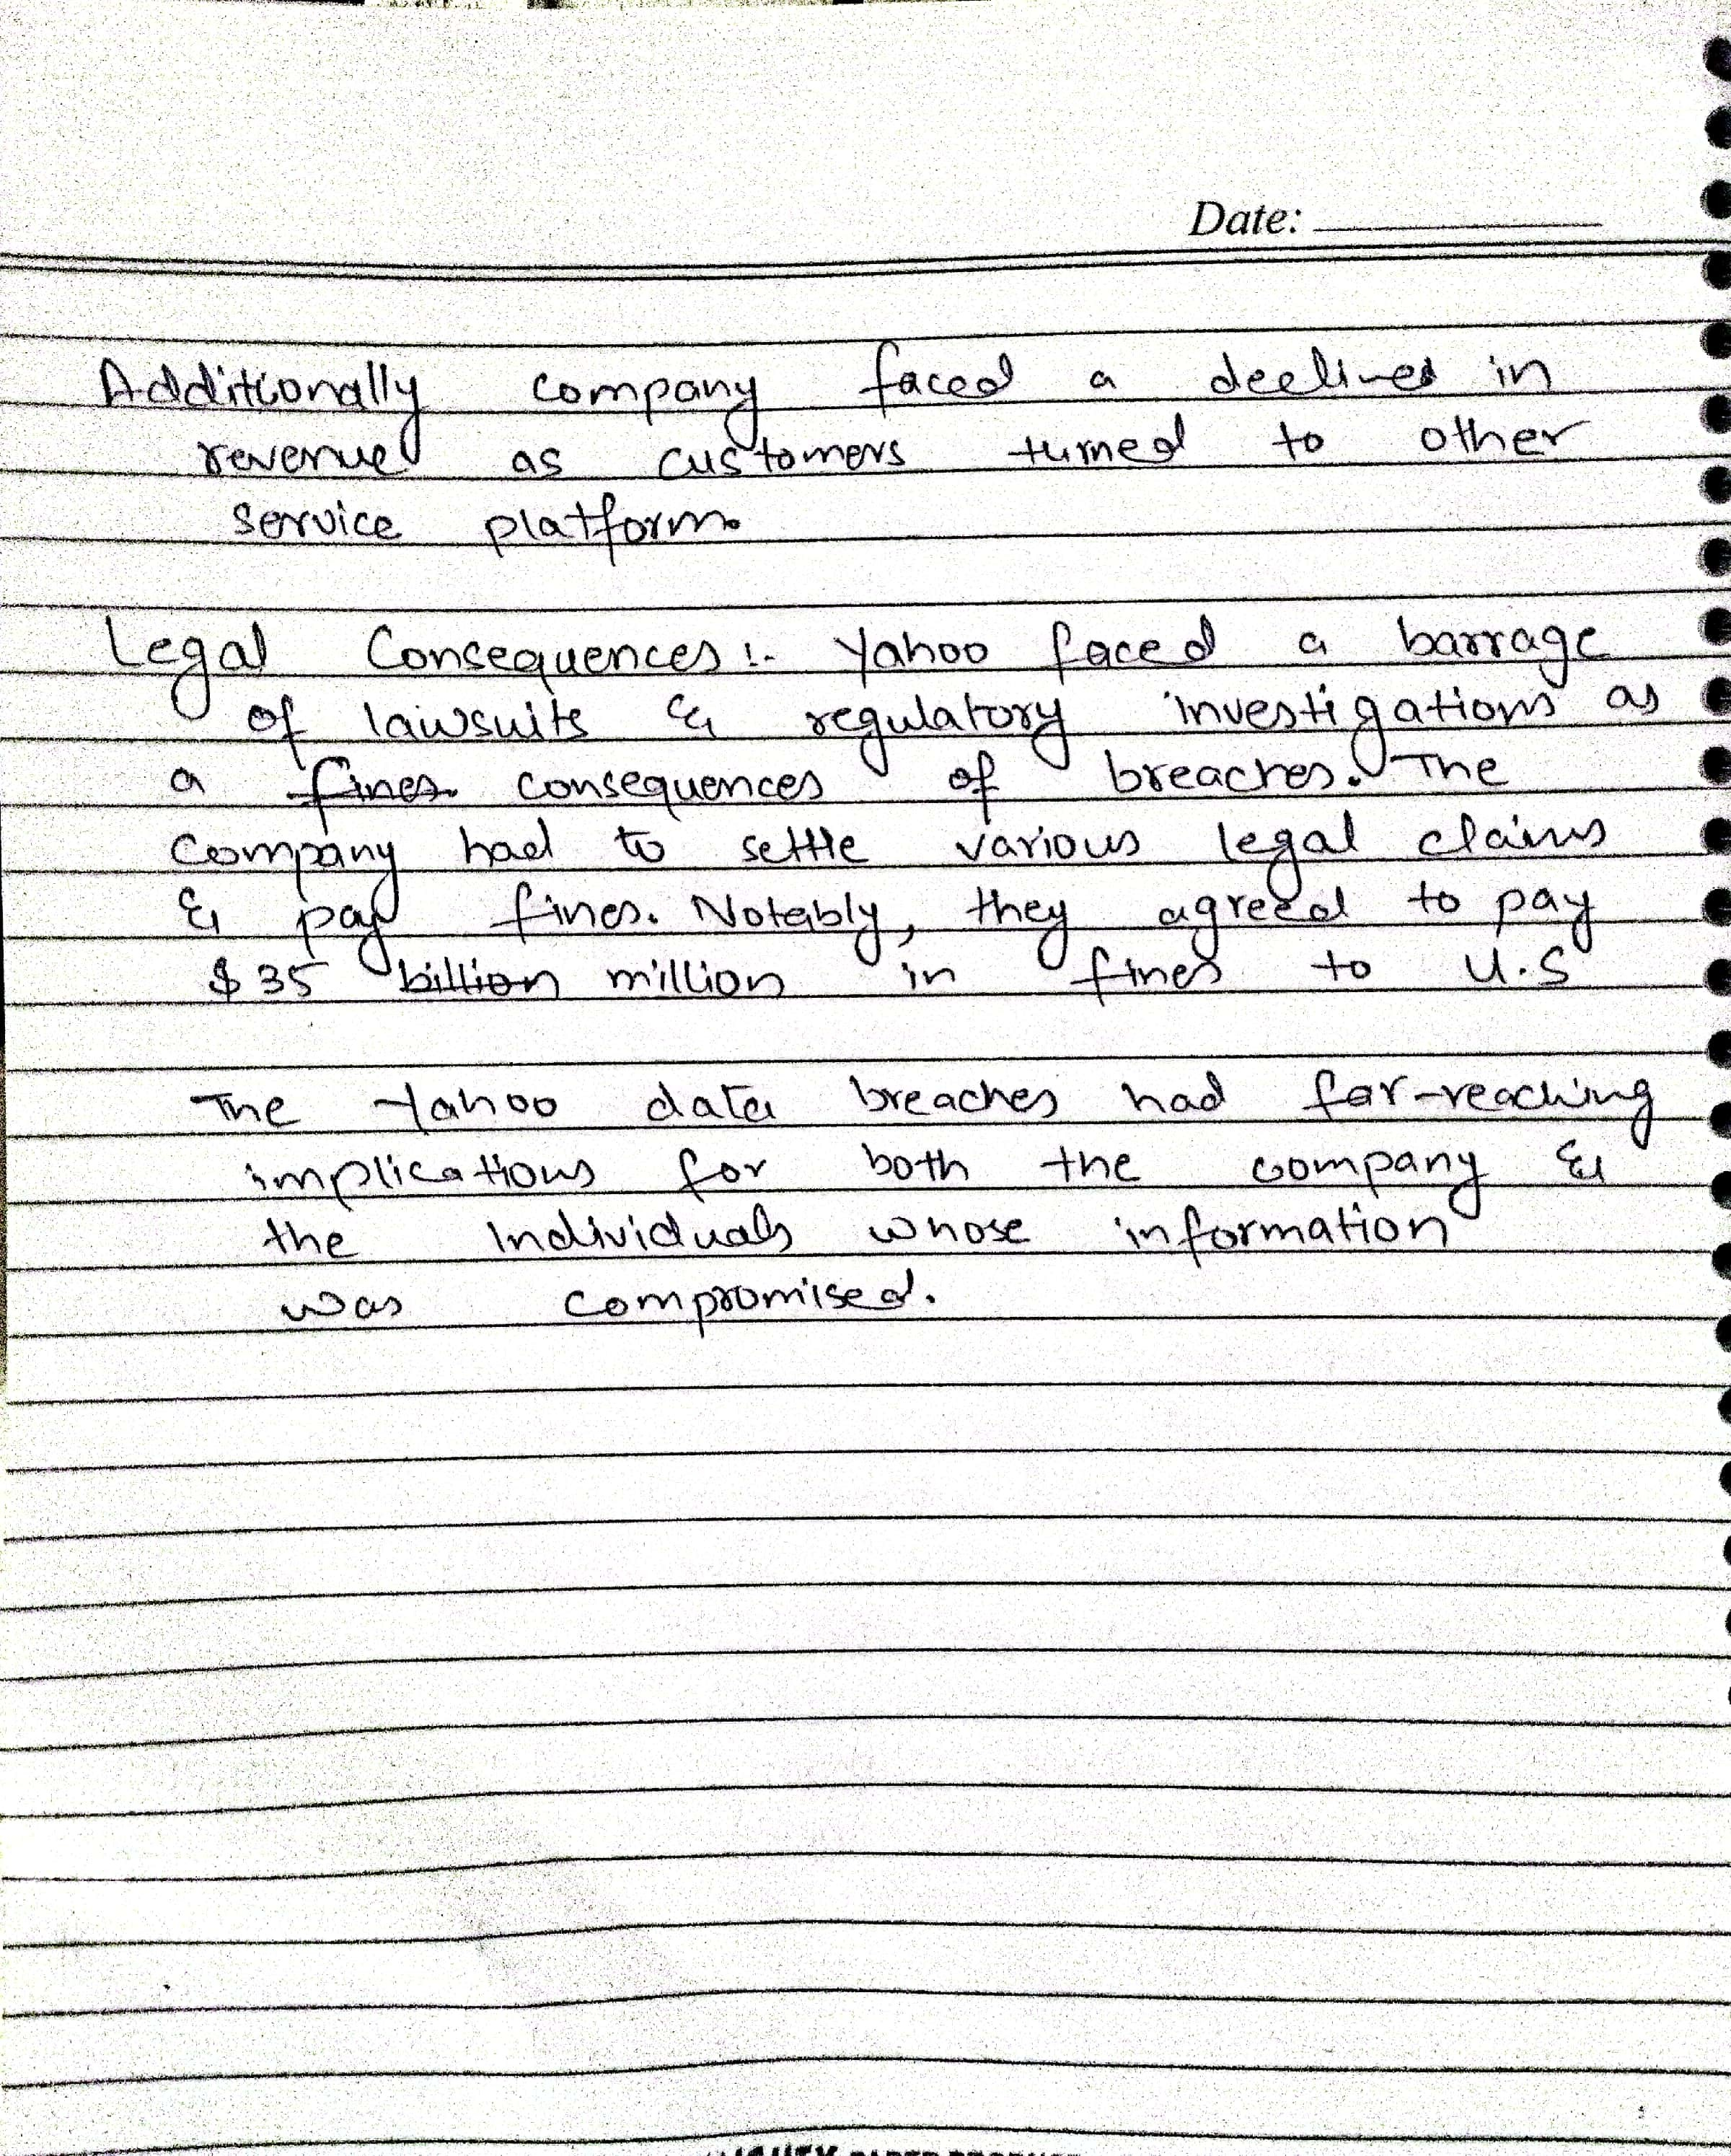

Q2. As part of your flourishing business, you have launched a Web Application for providing online services to your clients. For that, a Web Server & a Database Server have been deployed in your office space in which 50+ employees work in it. Discuss all possible “threats” on your deployed servers. **[CLO#1, 1.0 marks]**

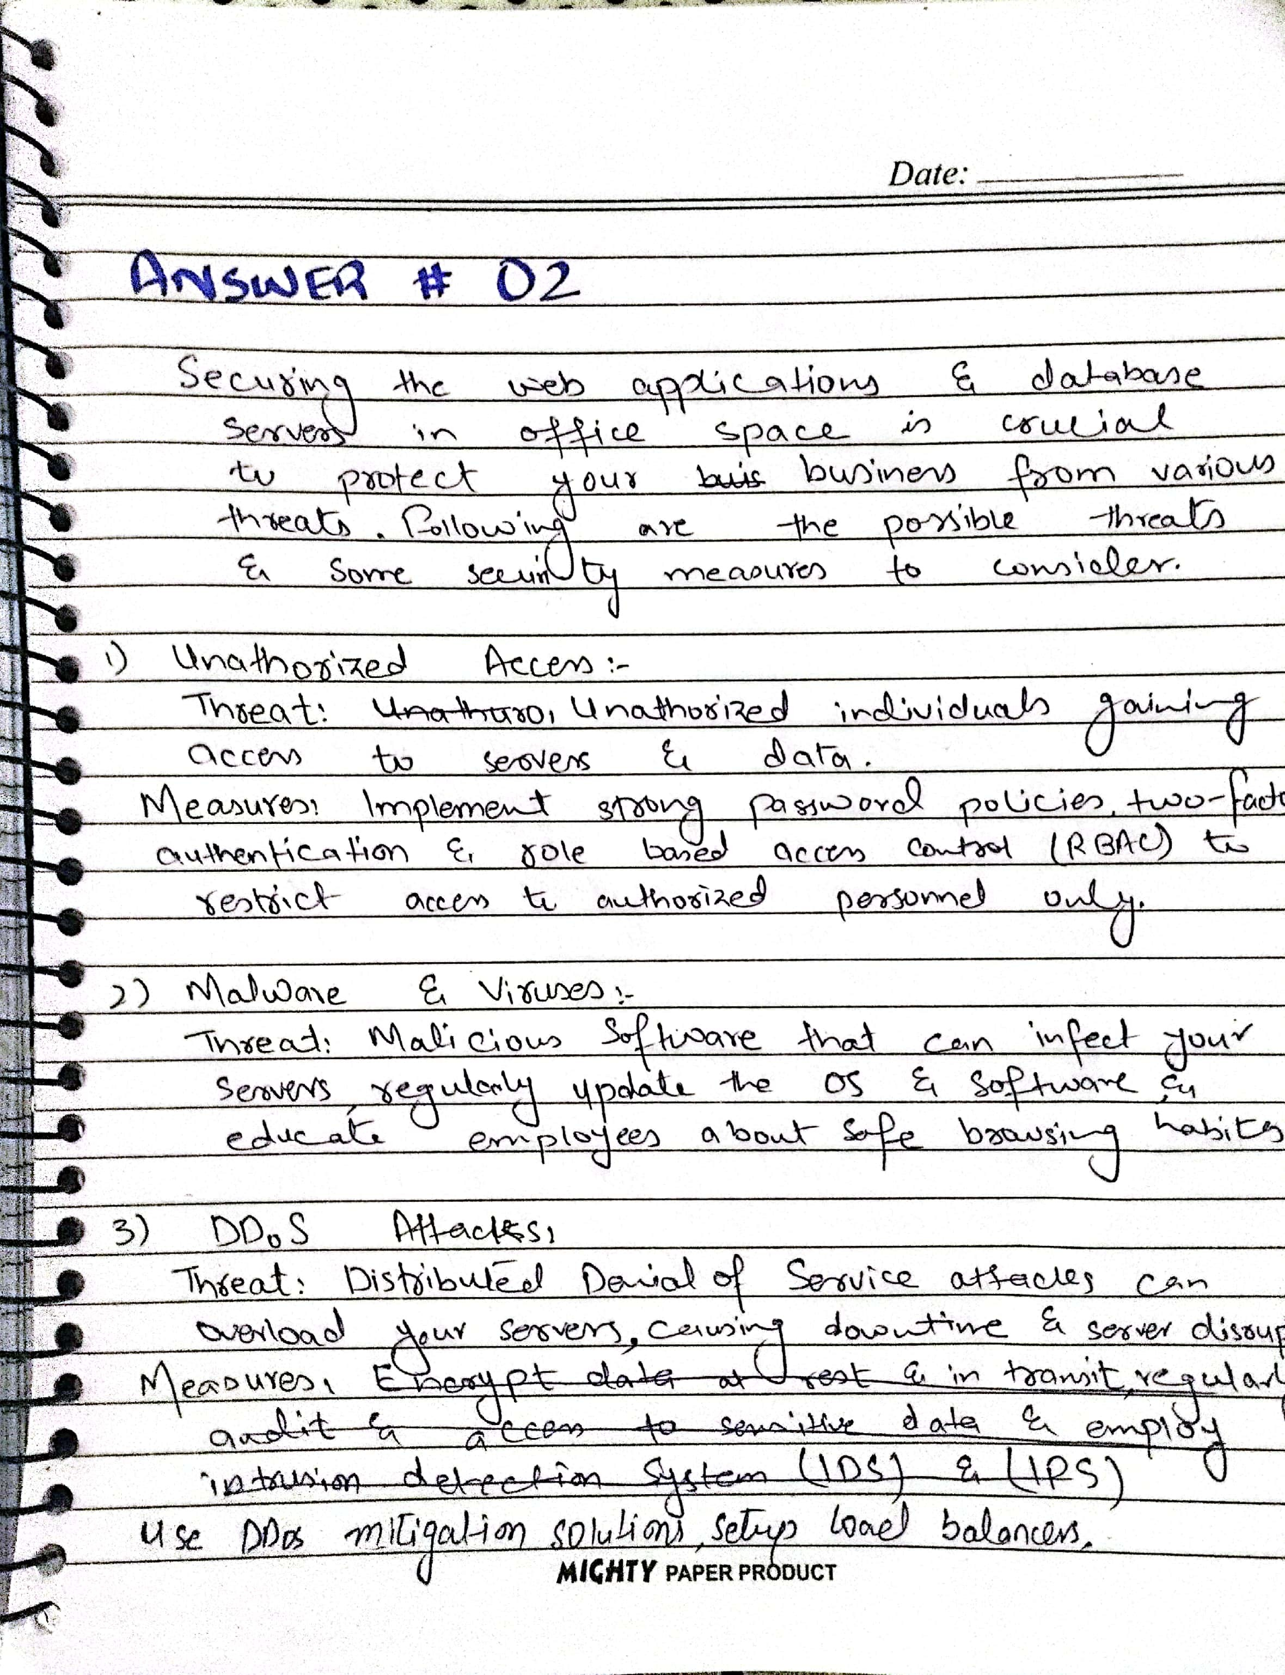

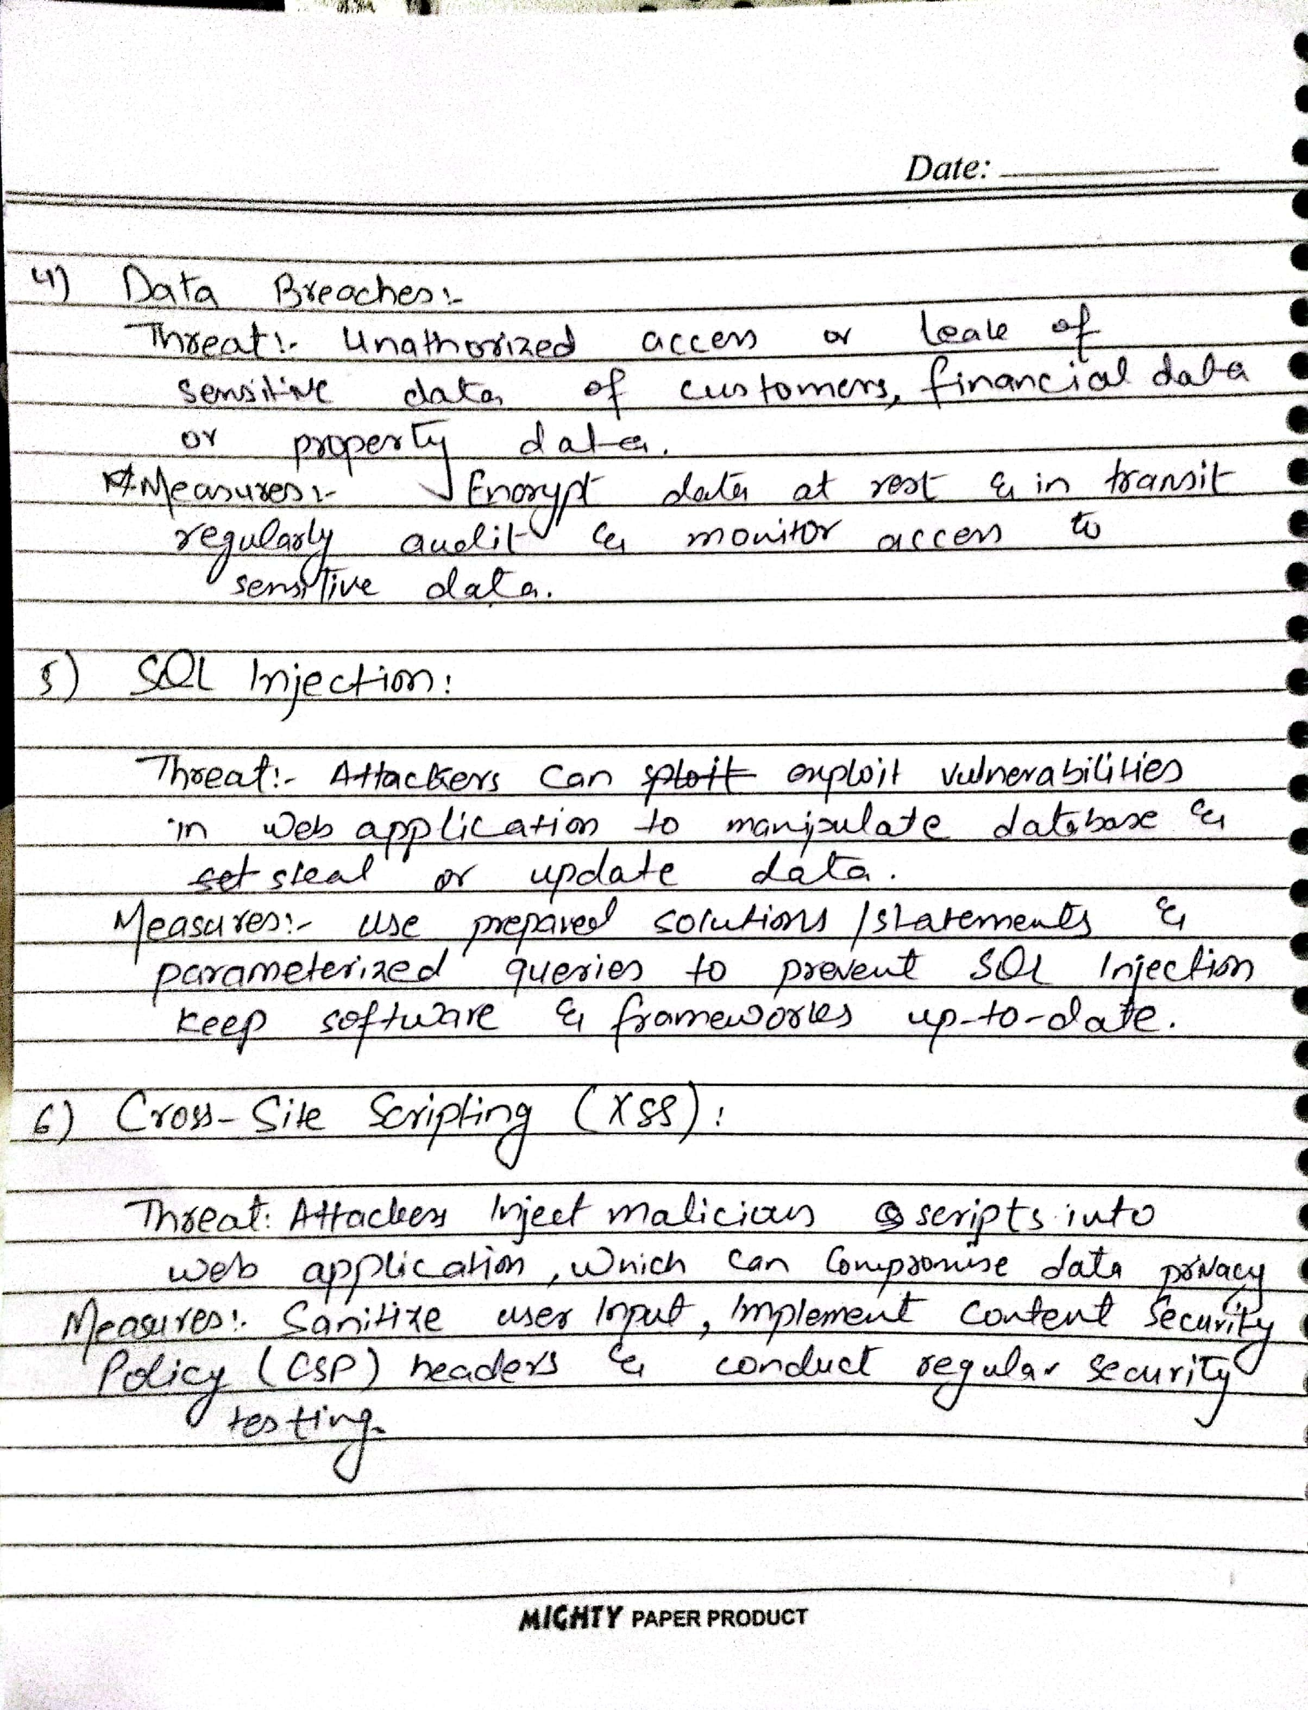

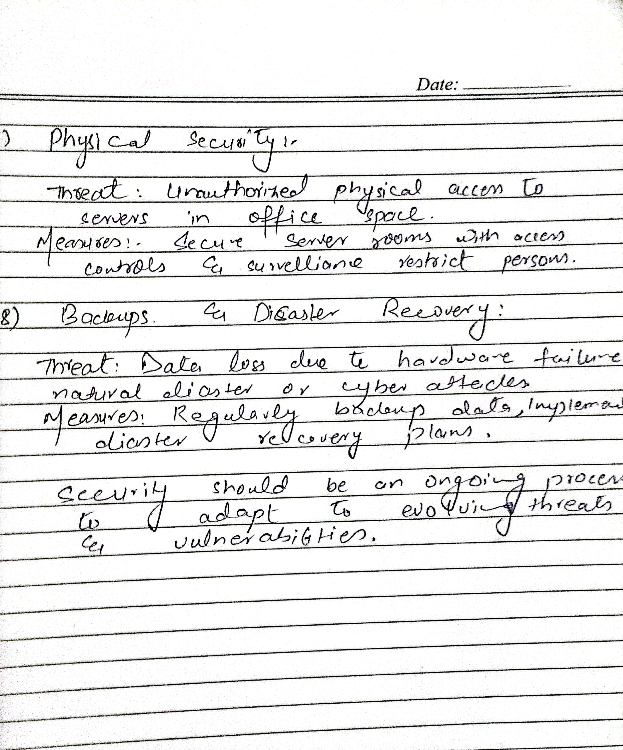

Q3. Taking the “McCumber Cube” into consideration, choose any two areas out of the 27 possible areas to secure. Analyze and discuss how these two areas can be implemented to strengthen the security poster of Bahria University Karachi Campus. **[CLO#4, CEP, 2.0 marks]**

